Compilation

Compilation is the translation of source code (the code we write) into object code (sequence of statements in machine language) by a compiler.
The compilation process has four different steps:
- The preprocessing
- The compiling
- The assembling
- The linking
Prerequisite Commands
Vim filename.c -> i-> write the code -> :wq
cat filename.c - (Display content of file)
#include<stdio.h>
int main() {
printf(“Hello”);
return 0;
}
Save the above code as main.c

1. The preprocessor
The preprocessor has several roles:
- It gets rid of all the comments in the source file(s)
- It includes the code of the header file(s), which is a file with extension .h which contains C function declarations and macro definitions
- It replaces all of the macros (fragments of code which have been given a name) by their values

The output of this step will be stored in a file with a “.i” extension, so here it will be in main.i. (but not saved in folder)

Command
gcc -E main.c
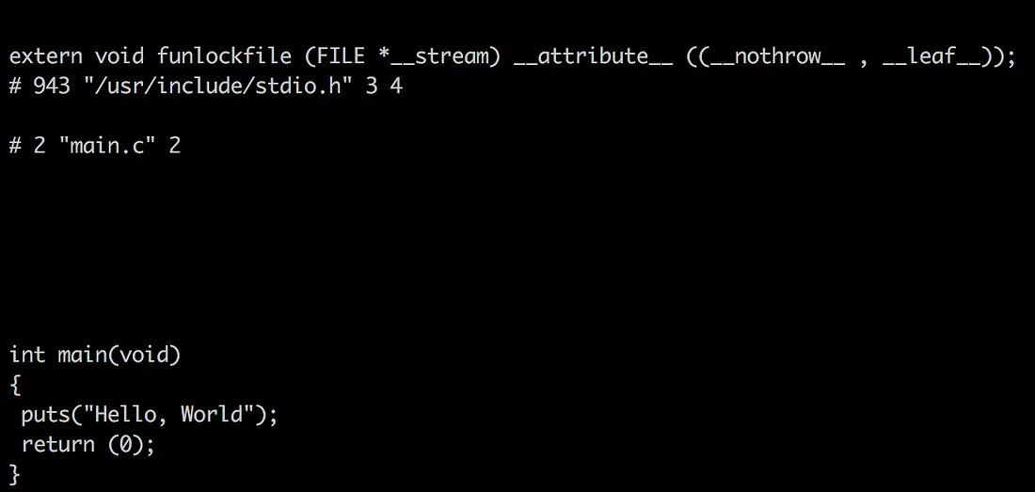
2. The compiler
The compiler will take the preprocessed file and generate IR code (Intermediate Representation) in main.s file.
Command
gcc -S main.c

3. The assembler
The assembler takes the IR code and transforms it into object code, that is code in machine language (i.e. binary). The main.o file is generated.
Command
gcc -C main.c

The linker
The linker creates the final executable, in binary, and can play two roles:
- linking all the source files together (combining 2 codes by linking object codes (a1.o with a2.o)).
- linking function calls with their definitions
Command
- By default: -gcc main.c creates executable program a.out. Therefore, we use ./a.out for execution.
- User Defined output filename -
gcc main.c -o my_prog creates executable program my_prog. Therefore, we use ./my_prog for execution.

